**IBM NALAIYA THIRAN**

**Virtual eye - Lifeguard for swimming pool to detect active drowning**

3e-HhWSW_400x400**TEAM ID : PNT2022TMID2564**

**Virtual eye - Lifeguard for swimming pool to detect active drowning**

Safety in swimming pools is a crucial issue. In this, a real-time drowning detection method based on HSV color space analysis is presented which uses prior knowledge of the video sequences to set the best values for the color channel

3e-HhWSW_400x400

3e-HhWSW_400x400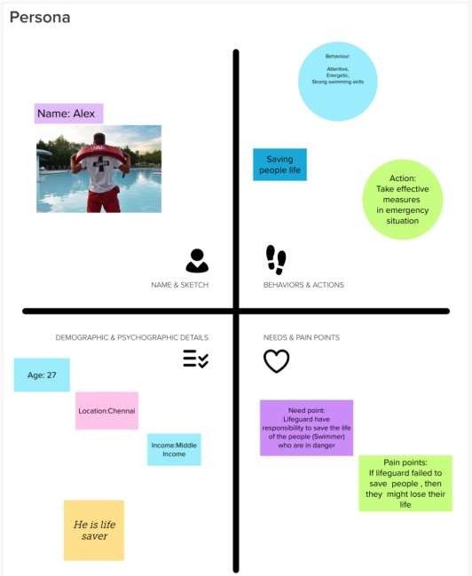Persona & Context (Empathy map)

3e-HhWSW_400x400

**TEAM ID : PNT2022TMID2564**

**TEAM MEMBER:**

**1. LALITHA K (210919106050) TEAM LEAD**

**2. ANITA A (210919106010)**

**3. ARTHI K (210919106013)**

**4. JEEVITHA K (210919106035)**

